**Set up a connector from Office 365 to your email server**

To create a connector in Office 365, click **Admin**, and then click **Exchange** to go to the Exchange admin center. Next, click **mail flow**, and click **connectors**.

If any connectors already exist for your organization, you can see them listed here.

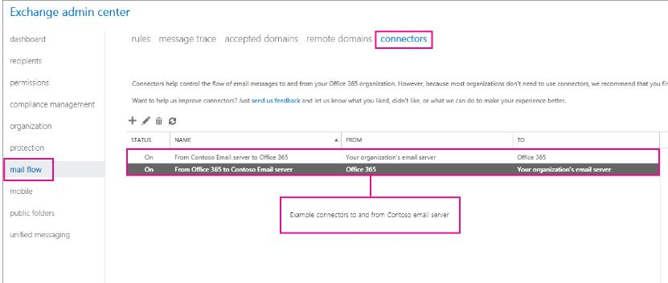

To start the wizard, click the plus symbol **+**. On the first screen choose the options that are depicted in the following screenshot:

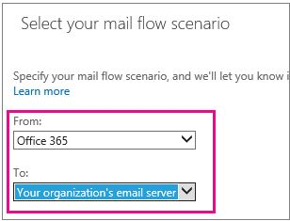

Click **Next**, and follow the instructions in the wizard & use following IP address list for this connector.

**IP ADDRESS LIST**

13.76.245.96, 13.67.57.59, 13.67.63.37, 13.67.62.73, 13.67.62.253

At the end, make sure your connector validates. If the connector does not validate, double-click the message displayed to get more information, and see [Fixing connector validation errors](https://technet.microsoft.com/en-us/library/ms.exch.eac.connectorlearnmoreaboutvalidationtasks(v=exchg.150).aspx) for help resolving issues.